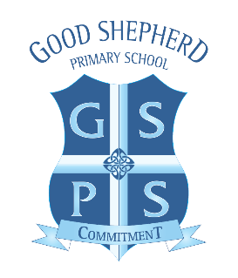

The Good Shepherd Primary School Holiday List 2024/25

School Closed for Children on:

Friday 27th September 2024 (Teacher Training Day)
Monday 28th October 2024 – Friday 1st November (Hallowe’en Holiday)
Monday 23rd December 2024 – Friday 3rd January 2025 (Christmas Holiday)
Monday 10th February 2025 – Friday 14th February 2025 (February Mid-Term Holiday)
Monday 17th March 2025 (St. Patrick’s Day Holiday)
Friday 18th April 2025 – Friday 25th April 2025 (Easter Holiday)
Monday 5th May 2025 (May Day Bank Holiday)
Monday 26th May 2025 (Bank Holiday Break)

As well as being holidays for the children, many of these days are School Development Days when the staff will be working on planning and general school improvement procedures.
All dates are subject to change. The school will endeavour to communicate any changes to closures as soon as the necessity arises.

